AMAZON SALES DASHBOARD
Data Analytics Portfolio Project — Project 2

Name: Sai Sri Kadari
Tools Used: Python | Pandas | Power BI
Date: March 2026
Dataset: Amazon Sales Dataset (Kaggle)
GitHub: github.com/saisrijagadish36-cmd/Amazon-Sales-Dashboard
Email: saisrijagadish36@gmail.com
LinkedIn: linkedin.com/in/sai-sri-kadari-229a2b230

PROJECT OVERVIEW
- What is this Project?
This project analyses Amazon India fashion sales dataset from Kaggle using Python and Power BI. The goal is to find key business insights about sales performance, customer behaviour and product trends.
- Dataset Information
- Dataset Name: Amazon Sales Report
- Source: Kaggle
- Total Rows: 1,28,975 orders
- Total Columns: 24 columns
- Time Period: April 2022 — June 2022
- Location: India
- Currency: INR (Indian Rupees)

- Tools Used
- Python (Google Colab) — Data Cleaning & Analysis
- Pandas Library — Data Manipulation
- Power BI Desktop — Dashboard & Visualization

- Project Goal
- Clean and prepare raw Amazon sales data
- Analyse revenue, orders and product trends
- Build an interactive Power BI dashboard
- Find actionable business insights

STEP 1: UPLOADING & LOADING DATA

- What I Did:
Uploaded the Amazon Sales CSV file to Google Colab and loaded it using Pandas library.
- Code Used:
from google.colab import files
uploaded = files.upload()

import pandas as pd
import io
df = pd.read_csv(io.BytesIO(uploaded['Amazon Sale Report.csv']),low_memory=False)
df.head()
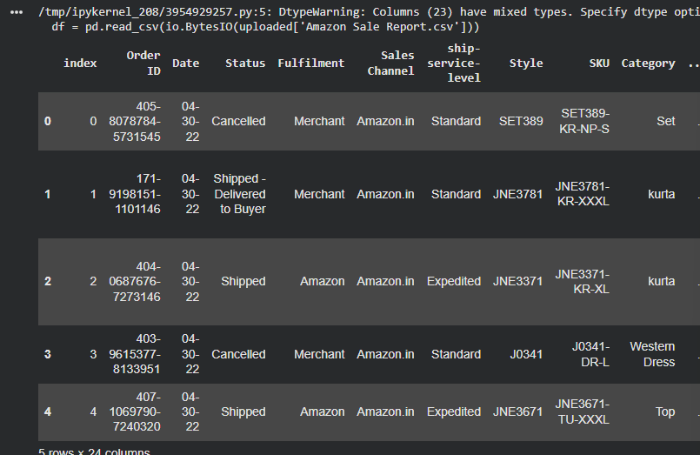
Why low_memory=False?
The dataset has mixed data types in some columns.
low_memory=False tells pandas to read the entire file at once to correctly identify data types.

- What I Found:
- File loaded successfully — 68MB file
- Data contains 1,28,975 rows and 24 columns
- Products include: Kurtas, Sets, Western Dress
- Cities across India — Mumbai, Bengaluru, Delhi
- All orders from April to June 2022

STEP 2: CHECKING DATA QUALITY
- What I Did:
Checked the size, columns and missing values of the dataset.

- Code Used:
df.shape # Check rows and columns
df.columns # Check column names
df.info() # Check data types & missing values
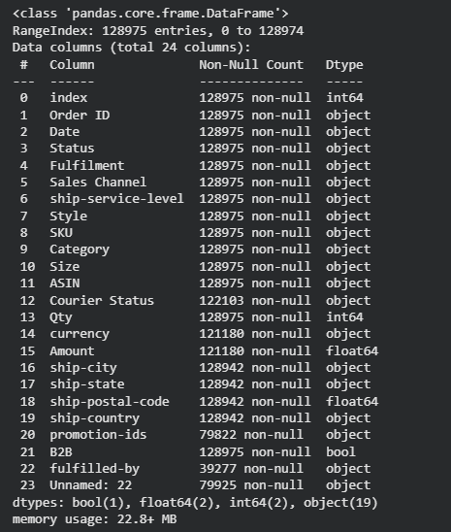
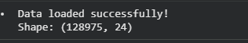

- What I Found:
- Total Rows: 1,28,975
- Total Columns: 24
- Missing Values Found: : 49,050 missing
- Courier Status: 6,872 missing
- Amount: 7,795 missing
- promotion-ids: 49,153 missing
- fulfilled-by: 89,698 missing
- ship-city: 33 missing
- Unnamed: 22

- Data Types:
- int64 : index, Qty
- float64 : Amount, ship-postal-code
- object : Category, Status, ship-state
- bool : B2B

STEP 3: DATA CLEANING
- What I Did:
Cleaned all missing values and removed unnecessary columns from the dataset.

- Code Used:
# Remove unnecessary column
df.drop(columns=['Unnamed: 22'], inplace=True)

# Fill missing values
df['Courier Status'] = df['Courier Status'].fillna('Unknown')
df['promotion-ids'] = df['promotion-ids'].fillna('No Promotion')
df['fulfilled-by'] = df['fulfilled-by'].fillna('Amazon')

# Drop rows with no Amount
df.dropna(subset=['Amount', 'currency'],inplace=True)

# Drop rows with no City
df.dropna(subset=['ship-city', 'ship-state'],inplace=True)
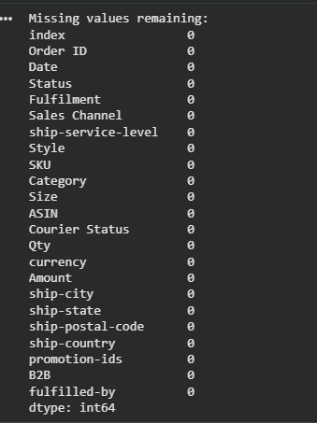
Cleaning Results:
- Removed Unnamed: 22 column ✅
- Filled Courier Status missing → "Unknown" ✅
- Filled promotion-ids missing → "No Promotion" ✅
- Filled fulfilled-by missing → "Amazon" ✅
- Dropped 7,795 rows with no Amount ✅
- Dropped 33 rows with no City ✅

Final Clean Dataset:
- Original rows : 1,28,975
- Removed rows : 7,826
- Final rows : 1,21,149
- Missing values : ZERO ✅

STEP 4: ADDING NEW COLUMNS
- What I Did:
Added 3 new columns to enable time-based analysis.

- Code Used:
df['Date'] = pd.to_datetime(df['Date'])
df['Month'] = df['Date'].dt.month
df['Year'] = df['Date'].dt.year
df['Month_Name'] = df['Date'].dt.strftime('%B')
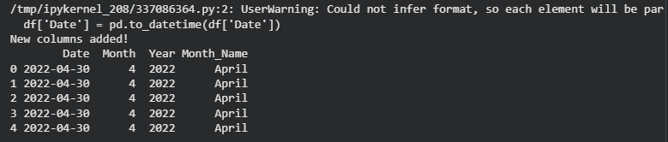
- Why I Added Each Column:
1️⃣ Month Column
Why? To find which month had highest sales.Extracted month number (4=April, 5=May, 6=June)
2️⃣ Year Column
Why? To identify which year data belongs to.All data is from 2022.
3️⃣ Month_Name Column
Why? To show month names instead of numbers in Power BI charts. (April, May, June)

- Result:
- Columns increased from 23 to 26
- Time analysis is now possible!

STEP 5: KEY PERFORMANCE INDICATORS
- Code Used:
print("Total Revenue :", round(df['Amount'].sum(), 2))
print("Total Orders :", df['Order ID'].nunique())
print("Total Quantity :", df['Qty'].sum())
print("Average Order :", round(df['Amount'].mean(), 2))
print("Total States :", df['ship-state'].nunique())
print("Total Categories:", df['Category'].nunique())
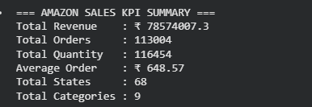
- What This Means:
- Store made ₹7.85 Crore in just 3 months!
- Average customer spends ₹648 per order
- Products sold across 68 Indian states
- 9 different fashion categories

STEP 6: SALES BY CATEGORY
- Code Used:
category = df.groupby('Category')['Amount'].sum().sort_values(ascending=False) .round(2)
print(category)
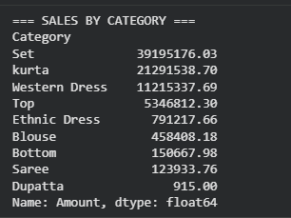
- Key Insights:
- Set category = 50% of total revenue!
- Top 3 categories = 90% of revenue
- Dupatta has almost zero sales
- Focus should be on Set & Kurta products

STEP 7: ORDER STATUS & STATE ANALYSIS
- Code Used:
# Order Status
status = df.groupby('Status')['Order ID'].count().sort_values(ascending=False)
print(status)

# Top States
states = df.groupby('ship-state')['Amount'].sum().sort_values(ascending=False).head(10).round(2)
print(states)
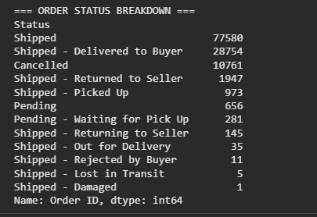
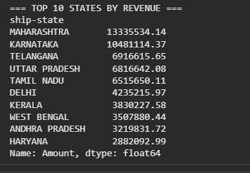
- Order Status Results:
- Shipped : 77,580 (60%) ✅
- Delivered : 28,754 (22%) ✅
- Cancelled : 10,761 (8.4%) ❌
- Returned : 1,947 (1.5%) ❌
- Top 5 States:
- Maharashtra : ₹1.33 Cr 🏆
- Karnataka : ₹1.04 Cr
- Telangana : ₹69 Lakh
- Uttar Pradesh: ₹68 Lakh
- Tamil Nadu : ₹65 Lakh
- Key Insights:
- 8.4% cancellation needs urgent attention!
- Maharashtra + Karnataka = 30% of revenue
- South India dominates sales

STEP 8: B2B, MONTHLY & SIZE ANALYSIS
- Code Used:
# B2B vs B2C
b2b = df.groupby('B2B')['Amount'].sum().round(2)
print(b2b)
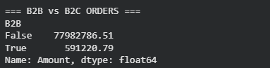
# Monthly Trend
monthly = df.groupby('Month_Name')['Amount'].sum().round(2)
print(monthly)
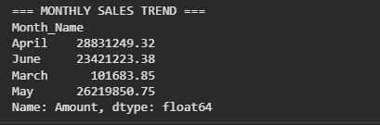
# Size Analysis
size = df.groupby('Size')['Qty'].sum().sort_values(ascending=False)
print(size)
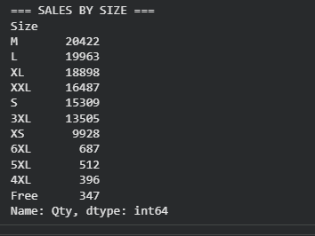

STEP 9: POWER BI DASHBOARD
- What I Did:
Exported clean Python data to Power BI and built an interactive dashboard.
- Steps Followed:
1. Exported clean CSV from Google Colab
2. Loaded CSV into Power BI Desktop
3. Applied professional theme
4. Built 7 visualizations
5. Added Category slicer for filtering

- Visuals Created:
│ 1 │ KPI Cards (Revenue/Orders/Qty)
│ 2 │ Sales by Category (Bar Chart)
│ 3 │ Sales by Month (Line Chart)
│ 4 │ Sales by State (Bar Chart)
│ 5 │ Order Status (Donut Chart)
│ 6 │ Fulfilment Type (Pie Chart)
│ 7 │ Sales by Size (Column Chart)

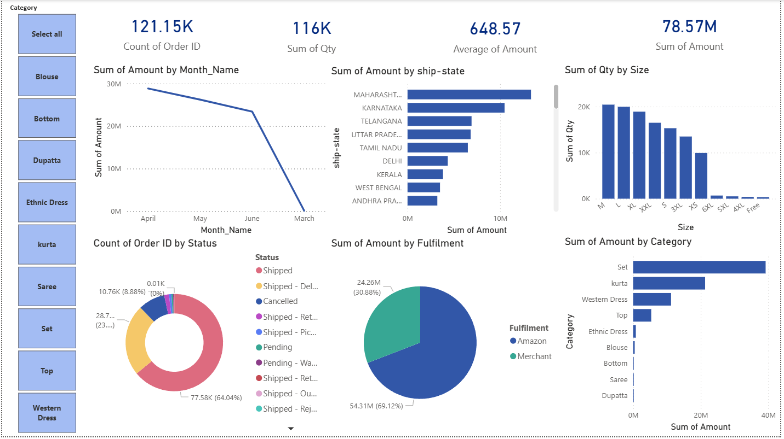

KEY INSIGHTS & RECOMMENDATIONS
Key Insights Found:
✅ Insight 1: Set Category Dominates Set category contributes 50% of total revenue at ₹3.91 Crore —focus here!
✅ Insight 2: High Cancellation Rate 8.4% cancellation rate (10,761 orders) is causing significant revenue loss!
✅ Insight 3: Maharashtra Leads Maharashtra contributes ₹1.33 Crore —highest revenue state in India
✅ Insight 4: Sales Declining Sales dropped from ₹2.88 Cr (April) to ₹2.34 Cr (June) — needs investigation!
✅ Insight 5: M Size Most Popular Medium size sells 20,422 units —ensure adequate M size inventory
✅ Insight 6: Amazon Fulfils Most Amazon fulfils 69% of orders —better delivery performance than Merchant

- Business Recommendations:
1. Investigate & reduce cancellation rate from 8.4% to below 3%
2. Focus inventory on Set & Kurta categories as they drive 73% of revenue
3. Expand marketing in Maharashtra & Karnataka as they are top performing states
4. Investigate why sales declined from April to June — seasonal trend?
5. Stock more M, L and XL sizes as they are most popular sizes

CONCLUSION
- What I Learned:
Through this project I learned how to:
- Load and handle large datasets (68MB)
- Clean complex real-world Amazon data
- Handle multiple types of missing values
- Create time-based analysis columns
- Build interactive Power BI dashboards
- Find actionable business insights

- Tools & Skills Used:
- Python — Data loading & cleaning
- Pandas — Data manipulation
- Google Colab — Cloud Python notebook
- Power BI — Data visualization
- GitHub — Portfolio hosting

- Project Files:
- Amazon_Sales_Dashboard.pbix — Power BI file
- amazon_dashboard.png — Dashboard image

- Dataset:
Available on Kaggle:
kaggle.com/datasets/thedevastator/unlock-profits-with-e-commerce-sales-data

- Connect With Me:
💼 LinkedIn : linkedin.com/in/sai-sri-kadari-229a2b230
🔗 GitHub : github.com/saisrijagadish36-cmd
📧 Email : saisrijagadish36@gmail.com

Thank you for reviewing my portfolio!

